**Software Requirements Specification (SRS) for Recipe Recommendation System**

**1. Introduction**

The Recipe Recommendation System is a software application designed to provide users with personalized recipe recommendations based on their food preferences. The system allows users to register, login, and browse a variety of recipes. It leverages external sources such as Google search to provide additional information and links related to the recipes.

**2. Purpose**

The purpose of this document is to outline the functional and non-functional requirements of the Recipe Recommendation System. It serves as a guide for the development team to understand the scope of the project and for stakeholders to evaluate the system's features.

**3. Scope**

The Recipe Recommendation System will consist of the following key features:

* User registration and login functionality
* Display of a variety of recipes with ingredients
* Ability to search for recipes by name
* Integration with Google search to provide additional recipe-related information and links
* Graphical User Interface (GUI) for user interaction
* Back-end database for storing user information and recipes

**4. Functional Requirements**

**4.1 User Registration**

* Users can register by providing a username, email, password, and confirming the password.
* The system validates the uniqueness of the email address.
* Users must agree to the terms and conditions to complete the registration.

**4.2 User Login**

* Registered users can log in using their username and password.
* The system authenticates the user's credentials and grants access upon successful login.

**4.3 Recipe Display**

* Upon login, users are presented with a variety of recipes.
* Each recipe includes its name and list of ingredients.
* Users can select a recipe to view additional information.

**4.4 Recipe Search**

* Users can search for recipes by entering keywords or names in the search bar.
* The system retrieves matching recipes based on the search query.

**4.5 Google Search Integration**

* The system integrates with Google search to fetch additional recipe-related information and links.
* Users can access external resources by clicking on the provided links.

**5. Non-Functional Requirements**

**5.1 Performance**

* The system should respond to user actions promptly.
* Database queries and external API calls should be optimized for efficiency.

**5.2 Usability**

* The GUI should be intuitive and user-friendly.
* Error messages and prompts should be clear and informative.

**5.3 Security**

* User passwords should be stored securely using encryption techniques.
* User authentication and authorization should be implemented to prevent unauthorized access.

**5.4 Reliability**

* The system should be robust and able to handle unexpected errors gracefully.
* Regular backups of the database should be performed to prevent data loss.

**6. System Architecture**

The Recipe Recommendation System follows a client-server architecture:

* Client-side: Graphical User Interface (GUI) developed using Tkinter library in Python.
* Server-side: Back-end logic implemented in Python, integrated with MySQL database for data storage.
* External integration: Google search API used to fetch additional recipe-related information.

**7. Conclusion**

The Recipe Recommendation System aims to provide users with a seamless experience for discovering and exploring new recipes. By incorporating user registration, login, and external integration features, the system enhances user engagement and satisfaction.

This document serves as a comprehensive guide for the development and evaluation of the Recipe Recommendation System, ensuring that it meets the needs and expectations of its users.

REGISTRATION PAGE:

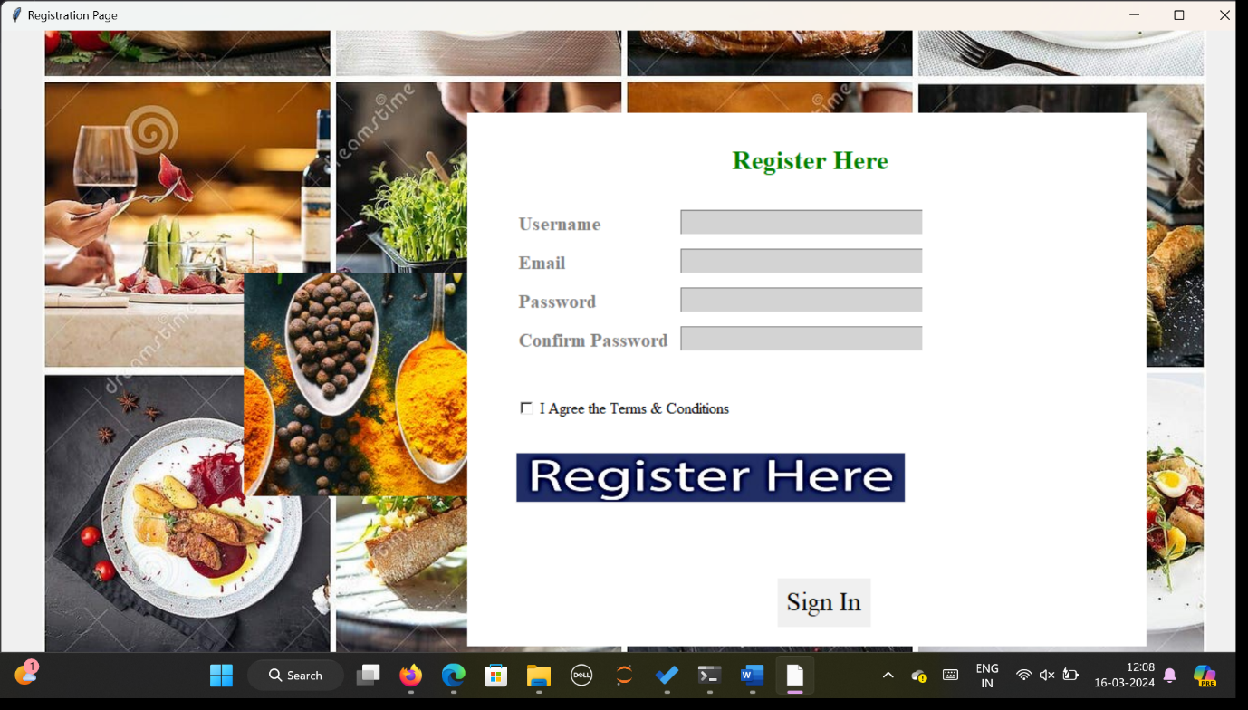

LOGIN PAGE:

SEARCH PAGE:

